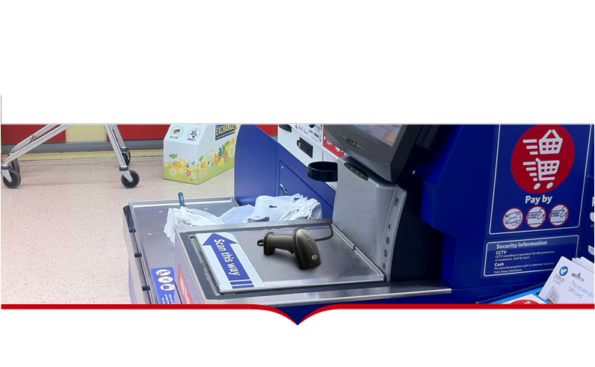

**2D Image handheld scanner XL-3220**

◎ Support 1D, 2D and GS1 Data Barcodes

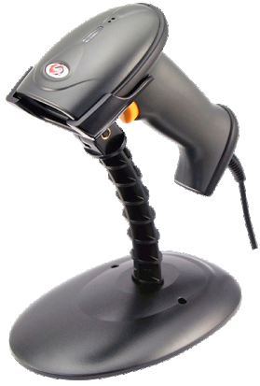

◎ Good performance on both display and printed label reading

◎ Rugged casing supports IP54 sealing protection

◎ Support multiple interfaces interchange by one scanner

◎ Designed especially for retail, cash register, health-care and public sector

|  |  |  |  |
| --- | --- | --- | --- |
| Model | XL-3220 | Cable Standard | 2m |
| Light Source | Red LED (Marking Light) White LED (Lighting) | Input Voltage | DC 5V |
| Image Sensor | CMOS | Working current | 230mA |
| Scan Mode | Manual & Continuous | Stand-by current | 150mA |
| Image Size | 640x480 pix | Indicator | LED Indicator and Buzzer |
| Scan Speed | 30 fps/s | Drop Test | 1.5m |
| Decoding Depth | 40~220mm (0.33mm pcs0.9, EAN13) | Interface | USB, Rs232, USB-VCP |
| Minimum Resolution | 4mil | Temperature (Operating) | -10°C-55°C |
| Print Contrast Signal | 15% | Temperature (Storage) | -20°C-60°C |
| Size | L × W × H:175mm × 73mm × 102mm | Humidity | 5% to 95% (non-condensing) |
| Case Material | ABS+PC | Light Levels | 0-100,000 Lux |
| Scan Angle | Rotation: 360° tilt: ±50° deﬂection: ±50° Field of view angle: horizontal 36° , vertical 23° | | |
| Decoding Capability | 1D: UPC-A; UPC-E; EAN-8; EAN-13; Code39; Codabar;Code128; Interleaved 2 of 5;Industrial 2 of 5; Matrix 2 of 5; Code 93; UCC/EAN 128; Code 11; MSI; UK/Plessey ; ISBN/ISSN; GS1 Databar Expanded; GS1 Databar; GS1 Databar Limited.  2D: QR code; PDF 417; Datamatrix | | |